- A riddle: What is in seasons, seconds, centuries and minutes but not in decades, years or days? (scroll down the page to see the answer)

2. How do you understand the following saying?
“When I came to the crossroads of my life, I found out I was out of gas.“

Possible interpretation:
When your life is at a crossroads, there is an important decision you need to make. Will you go to university or get a job? Will you get married and have a child or go to Australia to sheer sheep?
If you run out of gas, you have no energy left. The sentence means that when you needed to make an important decision, you were not able to because of a lack of energy.

- A joke:

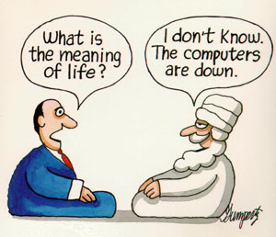

The answer to the riddle: letter n

Downloaded from:
cvičení 1 převzato dne 18.6.2011 z : http://dan.hersam.com/riddles.html
cvičení 3 převzato dne 18.6.2011 z: http://robertfoo.blogspot.com/2010/11/what-is-meaning-of- life.html

