Compare and contrast the two pictures. You may want to mention the following:
- the place, the atmosphere, the activity, the clothes

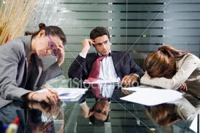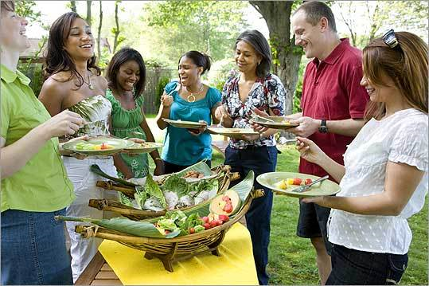

Downloaded from:
http://www.istockphoto.com/file_closeup/business/business-meetings/3673368-office-life.php?id=3673368
http://www.boston.com/bostonglobe/magazine/articles/2008/07/13/an_affair_to_remember/
19.3.2011

