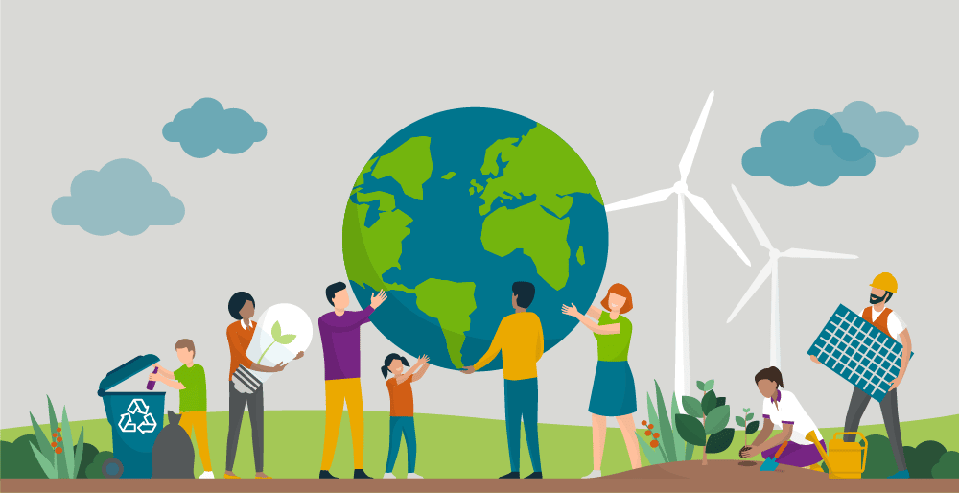**What can young people do to protect the planet Earth**

**Do some research and answer the following questions:**

1. **Reduce, Reuse, Recycle:**

What can you buy or use **less**? (reduce)

What everyday items can you use **again**? (reuse)

What can you recycle/sort out?

1. **Conserve Energy:**

How can you consume less energy?

1. **Support Sustainable Practices:**

What does the word SUSTAINABLE mean? What can be sustainable?

What does the word RENEWABLE mean? What are some examples?

1. **Plant Trees and Participate in Green Initiatives**

What are some „green“ activities you can join?

1. **Stand up for Eco-Friendly Policies**

What can you do to support eco-friendly decisions?

1. **Use Public Transportation or Carpool:**

How can you reduce carbon emissions?

1. **Raise Awareness:**

How can you let people know about what is important for the environment?

1. **Practice Water Conservation:**

How do you save or protect water?