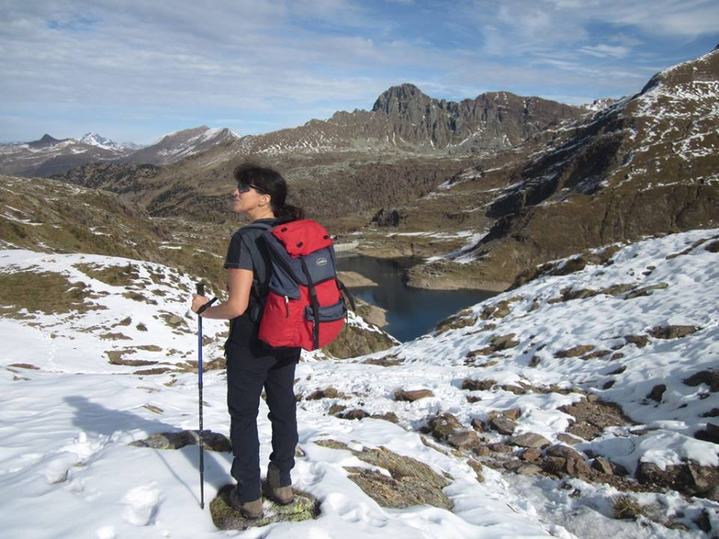
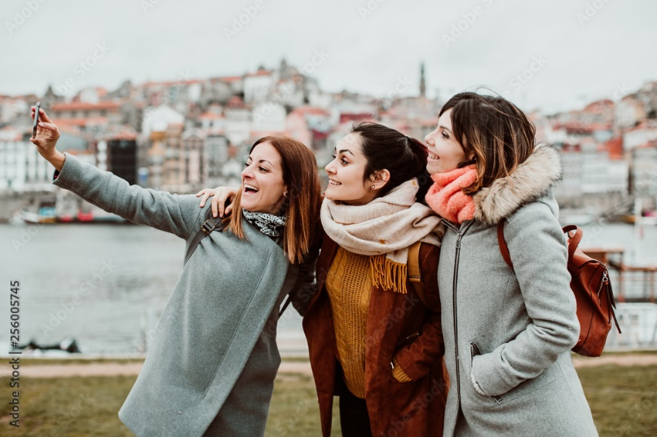

Describe:  - The place (Where is it?)  - Time of the day/season/athmosphere  - Activities (What are people in the picture doing?) | Compare/Contrast pictures  What do the pictures have in common?  Use the following vocabulary:  similar/different/both/THAN/same/on the other hand/different from/same as/however/although

There is/are (There are three girls in the city/in a town)
It is (a small/big) town
The atmosphere is relaxed, the girls are smiling.
They are taking a selfie.
The weather is cloudy and it may be autumn because they are wearing scarves and jackets.

Both pictures show people on vacation. People in the first picture are on sightseeing vacation WHILE the person in the second picture is on a hiking vacation. I think that sightseeing is MORE boring / MORE interesting / MORE expensive/ MORE fun THAN hiking
I think hiking is MORE difficult / hardER THAN sightseeing.

I personally prefer (sightseeing/hiking)

