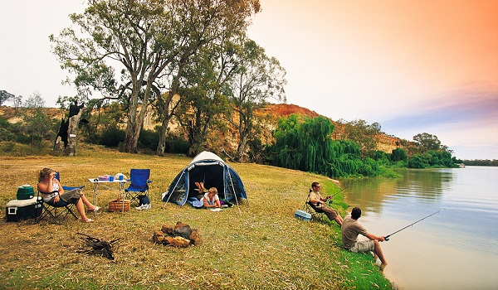
Describe:  - The place (Where is it?)  - Time of the day/season/athmosphere  - Activities (What are people in the picture doing?) | Compare/Contrast pictures  What do the pictures have in common?  Use the following vocabulary:  similar/different/both/THAN/same/on the other hand/different from/same as/however/although



