**Drama in nursery schools**

* **Theatre in education**

The term theatre in education refers to using theatre to pass on knowledge, attitudes or behaviour not only to the audience but mainly to those who participate.

* **Drama in education**
* Drama in Education is a method based on pedagogic and psychological principle

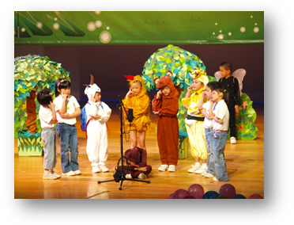

* Dramatic methods can include the commonly used methods of conversation, discussion, brainstorming, problem solving, methods of movement, music, literature, ...
* The basic *method* of drama is a dramatic game
* Personality development is the *main goal* of drama education, which is done through different role-plays

* **Teacher in role**
* This technique allows the teacher to control the possibility of teaching from the position inside
* He or *she takes a clearly defined role*, thanks to which the *teacher-in-role* can: stimulate interest of students, manage events, encourage students to join and participate, create tension and provide a situation in which the story may develop.

* The teacher *does not need to know how to play*, this technique only requires the teacher to *capture the role* and its function in the drama.

* **Games**
* They can break through shyness or mistrust
* Most of the games are enjoyed by pupils, they motivate them to learn
* Playing games is important part of drama, because they help to develop personality

* **Importance of drama in Pre-School education**
* Nursery school is a place that provides the best-organized playing atmosphere for children.
* In the safe and friendly atmosphere children find an opportunity for physical, mental, emotional and social development.
* During pre-school period children learn rules for collective living and develop an attitude for empathy and cooperation.

* **Drama in pre-school education:**
* Increases the creativity and imagination, the skill of taking decisions, thinking independently and the motivation to discover
* It contributes to *self-perception* of children and to development of positive *self-concept*
* It develops the feeling of cooperating with a group because there is group work
* It develops social sensitivity, feeling of responsibility, and  social skills, while increasing psycho-motoric skills, it creates coordination and balance, flexibility in movements, and agility
* It should have a place in pre-school education since it contributes to all the fields of development of pre-school children

* **What do children in nursery schools learn through drama techniques?**

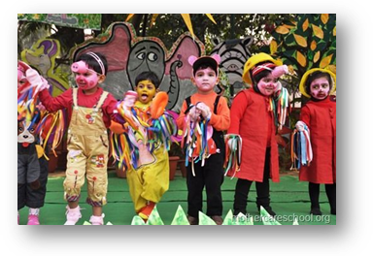

* To increase the creativity and imagination, the skill of taking decisions, thinking
* To develop communication skills by talking to their friends
* To develop the feeling of cooperating with a group
* To develop social sensitivity, feeling of responsibility
* To increase psycho-motor skills
* To improve and extend vocabulary
* To know more about jobs (actor, director)
* It contributes to self-perception of the children and to development of positive self-concept

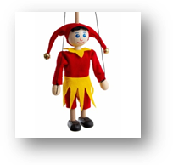



* **How do they practise drama?**
* Step into the role of an imaginary character
* Make masks, dress up (costumes, masks)
* Learn a fairy tale, perform a story /fairy tale
* Play with puppets
* Play dramatic games
* Do breathing exercises
* Songs, nursery rhymes, Christmas carols, lullabies
* Sing, dance, listen, clap hands, play on their bodies



**Vocabulary**

pedagogy (noun)- pedagogika

pedagogic, pedagogical (adjective)- pedagogický

pedagogically (adverb)- pedagogicky

agility [əˈdʒɪlɪtɪ] hbitost, mrštnost

lullaby [ˈlʌləˌbaɪ] ukolébavka

collective – společný, společně sdílený

self-perception [ˈself pəˈsepʃən] vnímání sebe sama

self-concept [ˈselfˈkɒnsept] sebepojetí

empathy [ˈempəθɪ] pochopení, vcítění se

cooperation [kəʊˌɒpəˈreɪʃən] spolupráce

psycho-motoric skills [ˈsaɪkəʊ-]

coordination [kəʊ ɔːdɪˈneɪʃən] sladění, soulad

balance [ˈbæləns] rovnováha

flexibility in movements [ˌfleksɪˈbɪlɪtɪ əv ˈmuːvmənt] ] flexibilita pohybů

pedagogy [ˈpedəˌgɒdʒɪ**]**– the methods and principles of teaching

pedagogue [ˈpedəˌgɒg] = teacher

puppet [ˈpʌpɪt]loutka, marioneta 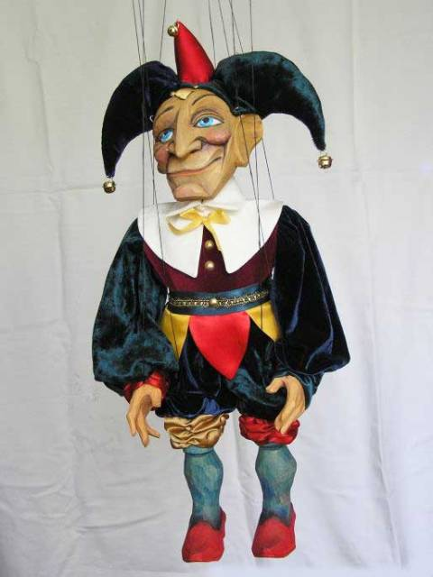(1)

hand puppet – maňásek

(2)

learn to do – naučit se udělat, learn about – učit se o, learn that – naučit se že

Zdroje

* 1. <https://www.google.com/search?q=marioneta+obr%C3%A1zek&tbm=isch&source=iu&ictx=1&fir=OgITTcpqO1HZdM%252C7VzCd2qBDhBKuM%252C_%253BqjVttgn7bKmj0M%252Cz1fLaG4-1oC9gM%252C_%253BEcI0ikgN6zKHdM%252C7VzCd2qBDhBKuM%252C_%253Bp-Aj2__fY9sZPM%252Cz1fLaG4-1oC9gM%252C_%253BM9GsXBWb03JYZM%252C7VzCd2qBDhBKuM%252C_%253Bs44O2tRVHhB2EM%252CezVTry4g49bkbM%252C_%253BpPF1LJbuNO9y3M%252CfAuJyAgSmR9lzM%252C_%253BCioobILPb2DO6M%252CEiv4Y21f41tlTM%252C_%253Bk8uaGb6aUUTnDM%252Cu0Z_3VeSOr6otM%252C_%253Bjgk5PP_7Y0oqhM%252C7vHMGikHtVu_tM%252C_&vet=1&usg=AI4_-kSKHD4FPUFKota0rIuLgXJqcqndZg&sa=X&ved=2ahUKEwjO0LKbm6D0AhXR_rsIHUn6DukQ9QF6BAgDEAE#imgrc=PwS6pBWEYBDxNM>
  2. <https://www.google.com/search?q=ma%C5%88%C3%A1sek+obr%C3%A1zek&tbm=isch&source=iu&ictx=1&fir=G939ofV8UVpDWM%252CrzkDSKEXnNaQsM%252C_%253BeYH8Yz5udb3PMM%252CsW7DQ_qSneoUVM%252C_%253BkuA5Hl6Ok4xn_M%252CsW7DQ_qSneoUVM%252C_%253BtC8cdE2y8z0X1M%252CzcChOTKWBfpalM%252C_%253BVMrVGhMmu_koDM%252Ca0BNcT5d4e_4gM%252C_%253B634oyVLpLWS9OM%252CY3_yNCsQimsxMM%252C_%253BsR-jOqPwQP_wKM%252Cw88v4B34BMH0FM%252C_%253BnomPZO-HzcAyqM%252CBH4o0SHCrRyhcM%252C_%253BHWgtPgpbQF17UM%252CmLdeb3jgmVQmbM%252C_%253BqaaBc6JSYgfpgM%252CxgV9YBu-5ghH0M%252C_&vet=1&usg=AI4_-kQx9bTZwvv-Bo3P5Yw1PmbnvwEjZg&sa=X&ved=2ahUKEwiuw5XLnaD0AhWMh_0HHaCxBvAQ9QF6BAgFEAE#imgrc=VMrVGhMmu_koDM>