**Using toys in nursery schools**

**A toy** = an object used for playing

* must be functioning, variable, emotionally attractive
* should be useful in education
* e.g. dolls, teddy bears, plush toys, prams and carriages, cars, slot cars (= autodráha), bricks (= kostky), building sets (= stavebnice), board games, beads (= korálky), puzzles, doctor´s sets…

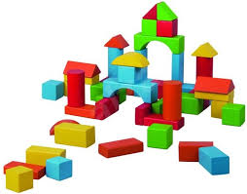

**Criteria when buying a toy:**

1. **Safety**

* safe materials
* the toy must be suitable for a certain age (e.g. for children under 3)

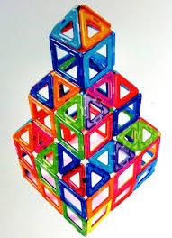

1. **Right size**

* not small pieces for small children in order not to swallow them
* not sharp
* non-functioning toy can be dangerous (e.g. from China)

1. **Use in education**

* should be variable = we can use it in many ways in education (e.g. memory game = pexeso can be used for teaching animals or for searching the cards in the classroom)

1. **Taste / vkus/**

* toys should be made from natural materials, fabric, represent the folklore of the country (opposite = plastic shining colourful toys with unreal faces from China)

1. **Suitability for a certain age**

* e.g. a folding book (= leporelo) is for 2-year-old children, a book is for older children
* e.g. Duplo is for younger children (2 years+) while Lego is for older children (6 years+ at least)

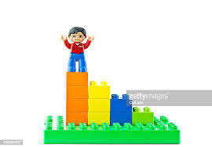**Duplo**

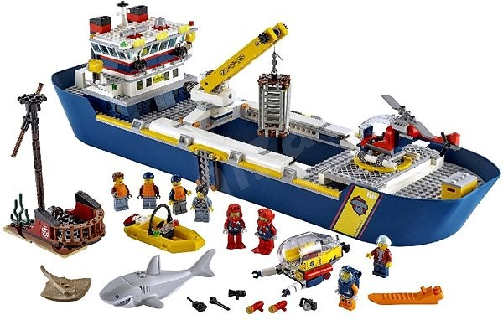**Lego**

**My experience**

What was your favourite toy when you were a child? Why?

What toys are used in nursery schools the most nowadays?

What toys would you buy for your children if you were a parent? Why?

What is your experience with using toys form your practical training?

Vocabulary

functioning [ˈfʌŋkʃənɪŋ] fungující, funkční

variable [ˈveərɪəbəl] proměnlivý

useful [ˈjuːsfəl] užitečný

teddy bear [ˈtedɪ] plyšový medvídek

plush toy [plʌʃ] plyšová hračka

pram [præm] kočárek dětský, AM baby carriage AM – americká angličtina

pushchair – kočárek sportovní , golfáč, AM sports stroller

(natural) fabric [ˈfæbrɪk] (přírodní) tkanina, látka, textilie

folklore [ˈfəʊkˌlɔː] folklór = část lidové [kultury](https://slovnik-cizich-slov.abz.cz/web.php/slovo/kultura) zahrnující slovesné/slovní, hudební, [dramatické](https://slovnik-cizich-slov.abz.cz/web.php/slovo/dramaticky) a taneční projevy; lidová [kultura](https://slovnik-cizich-slov.abz.cz/web.php/slovo/kultura) vůbec