Games in education

1. **What is a game?**

It is an activity for children

- it is played at home or in a nursery school, outdoors or indoors

**2.** **Types of games**

a) creative games – handcrafts/*rukodělná práce*/, art (e.g. painting, drawing, colouring pictures, sticking, cutting) - with pencils, crayons/*pastelky*/, chalks/*křídy*/, glue/*lepidlo*/, scissors, stickers /*nálepky*/

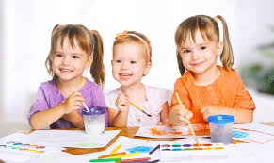

b) kinaesthetic = motional games – doing exercise /roll – kotrmelec/, ball games, miming/*pantomima*/, dancing with nursery rhymes, songs, poems, jumping the rope/*skákání přes švihadlo*/,

playing hide-and-seek/*hra na schovávanou*/, playing blind man´s buff /*hra na slepou bábu*/

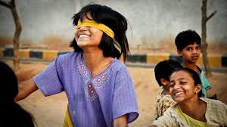

c) outdoor games = in the playground, in a sandpit/*na pískovišti*/ (making sand cakes, building sand castles),

- slides, swings, climbing frames (BrE) x monkey bars (AmE)/prolízačky/

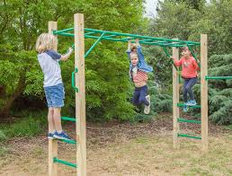

d) board games /deskové hry/– e.g. pairs /pexeso/, jigsaw puzzles /puzzle/, playing ludo/obdoba Člověče, nezlob se/, playing cards/hraní karet/, playing domino

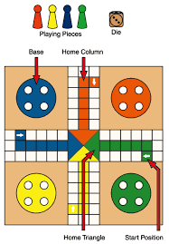 **Ludo**

e) word games – last first/slovní fotbal/, associations, nursery rhymes/dětské říkanky/, tongue twisters/jazykolamy/

f) children´s computer games – e.g. maze/bludiště/, memory games/el.pexeso/ – 12, 16, 24 or 30 cards/, tetris /kostičky - počítačová hra tetris, rozšířená po světě od r. 1984/

g) playing with toys – e.g. dolls and baby carriages AM(or prams BR), plush animals /*plyšová zvířátka*/(teddy bears), cars, cranes /jeřáby/, bricks, building set /stavebnice/, threading the beads/navlékání korálků/

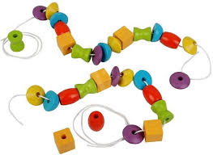

- playing doctors /hraní na doktora/, playing a family...

h) other – e.g. songs, relaxing games

1. **Advantages of games**

- they improve /*zlepšují si*/motional skills, language, logic and social skills

- children socialize = make friends and are in contact with their peers

- children learn basic things (e.g. colours, numbers, animals)

- children learn fair play

- children learn how to follow rules /jak se řídit pravidly/ and how to lose /jak prohrávat/

- games support imagination, individual development, concentration

**4. My favourite games (when I was a child)**

1. **My experience from my practical training in a nursery school**

**Vocabulary**

crayon [ˈkreɪən] pastelka, voskovka, kreslicí uhel

scissors [ˈsɪzəz] nůžky; scissors are …

colouring pictures – vybarvování obrázků colouring book - omalovánky

motional games [ˈməʊʃənəl] pohybové hry

Children are moving. – Děti se hýbou.