**Read these film reviews and choose the word that best describes it**

**AVATAR (2009)**

One of the most successful films of all time, *Avatar* (directed by James Cameron) tells the story of a reluctant hero who sets off on an epic adventure to save the alien world he has learned to call home. Now available in 3-D and 2-D this visually **spectacular** film is **a** **must-see** for all the family with important messages for both young and old

**a** nauseating **b** inspiring

**с** unrealistic

**THE PROPOSAL (2009)**

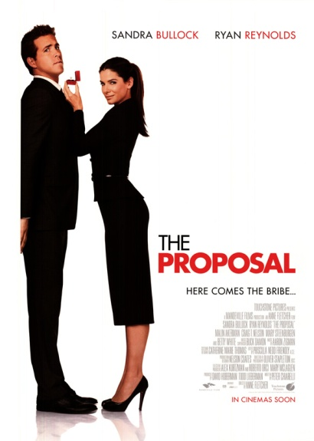 An ambitious and obnoxious boss (played by Sandra Bullock) hears that she will have to return to Canada as her visa has run out. To avoid deportation, she forces her young assistant (Ryan Reynolds) to marry her so that she can stay in the United States legally. After many crazy adventures to prove to his family that they do actually love one another, they finally really fall in love. This is a good

old-fashioned **feel-good comedy** which is the perfect vehicle for both stars

**a** entertaining **b** nonsense **c** moving

**A NIGHTMARE ON ELM STREET (2010)**

As a fan of horror films, I was looking forward to this remake of the Wes Craven cult classic which first appeared on our screens almost twenty years ago. Terrifying when it first came out, this remake, however, doesn’t compare in any way. The special effects are **laughable** and the acting is **wooden**. I’d recommend watching the original any day and I certainly hope they don’t bother to remake the others****

**a** gripping **b** annoying **c** rubbish

**YOUNG VICTORIA (2009)**

Nominated for three Academy Awards and winner of Best Costume Design, this is a perfectly crafted period drama. **The film stars** Emily Blunt as the young Queen Victoria and Rupert Friend as her husband Albert. **It tells the story** of the first few years of her reign with all the dramas and emotions that a young woman in her position would have to face. The acting by both young stars is excellent and totally **believable** **a** annoying **b** nonsense **c** moving 

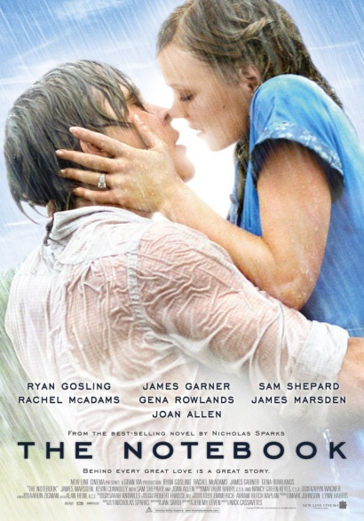 **THE NOTEBOOK (2004)**

If you enjoy **sickly sweet romantic films** that unashamedly **tug on the heart strings to** make you cry, then this is most definitely the film for you. From the moment the film begins you know where it is taking you. A boy meets a girl. The boy is poor and the girl is rich. The girl’s parents don’t approve. Fast forward to years later … Have your box of tissues to hand!

**a** nonsense **b**  nauseating **c**  gripping

**THE BOURNE ULTIMATUM (2007)**

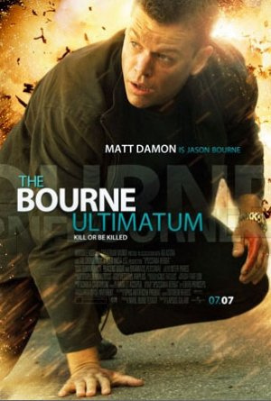This is the third in the Bourne series starring the excellent Matt Damon. Filmed on location in Tangier, London, Paris, Madrid, Berlin and New York City, the story is fast-paced but to my mind rather confusing. My concentration was disturbed by the hand-held camera effect which meant that the film was constantly ‘shaking’. I appreciate that this was supposed **to heighten the tension** but I found it almost impossible to focus in places.

**a** unwatchable **b** unrealistic **c** exciting